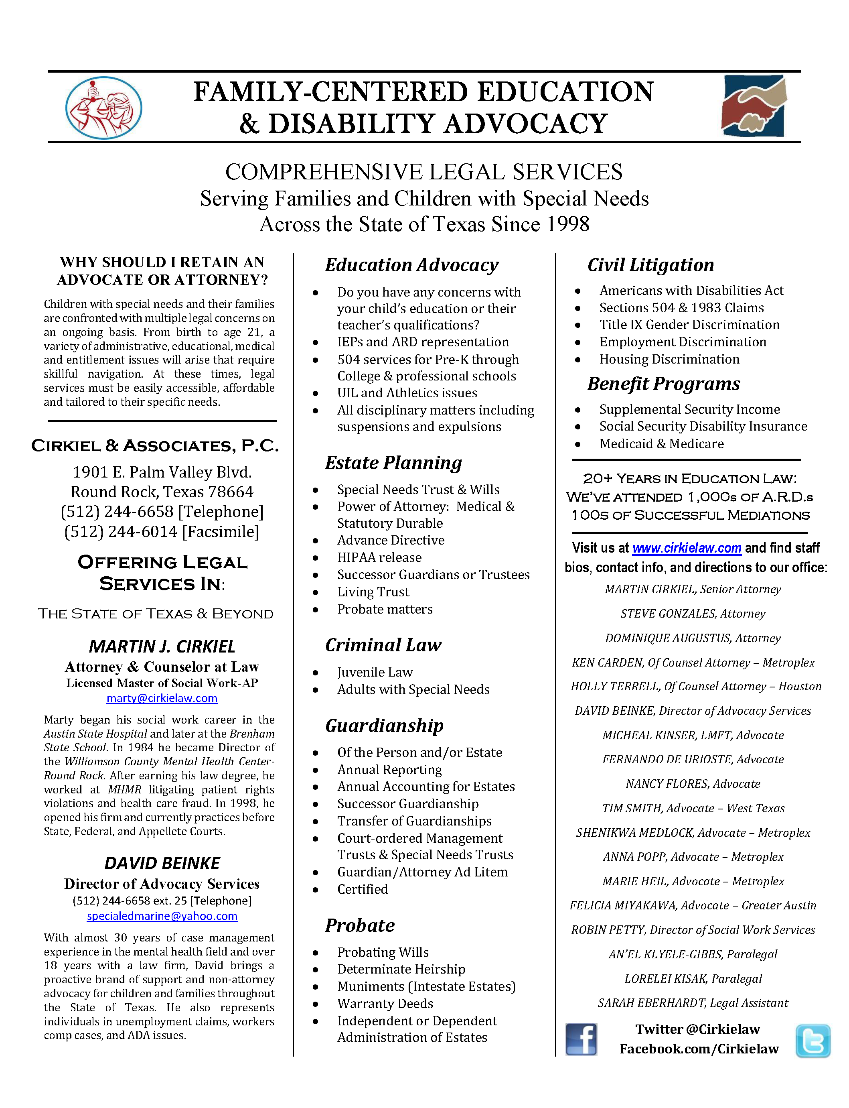

Parent/Caller information
Name of parent(s) / custodian(s) / guardian(s):
How you did you hear about our firm?
Address:
Primary Phone:
Secondary Phone:
Primary Email:
Secondary Email:
Occupations of family members:
What is the status of the student’s parents? ☐ Married ☐ Divorced ☐ Single Parent ☐ Other
Please see question #18 on page 4 to detail any relevant family or parenting concerns.
Would you like information on drafting Estate Documents for you and/or your family members? ☐ yes ☐ no
These include a Will, Power of Attorney(s) (Medical, Durable, & Educational), a HIPAA release, Declaration(s) of Guardian for children/self, an Advance Directive to Physician, & Special Needs Trust(s).
Student information
Name:
Date of Birth:
Grade:
What is the student’s Ed classification? ☐ Special Ed (IEP) ☐ 504 Plan ☐ General Ed?
School District at issue:
Current District If Different:
School:
Student ID:
Last four of SSN#:
Insurance/Benefits information
Does the student have health insurance? ☐ yes ☐ no
If yes, what type (example: Medicaid, Cigna, Blue Cross)?
Does the student receive Social Security Benefits (SSI, RSDI)? ☐ yes ☐ no
If no, would you like information on benefits? ☐ yes ☐ no
Is the student seen by a Local Mental Health Authority (MHMR)? ☐ yes ☐ no

Our attorneys & advocates offer several different consultation options. Please indicate the choice that best fits your needs:

Martin Cirkiel, Senior Attorney (phone or in person)
☐ $350 for a one-hour consultation

Associate Education Attorney (phone or in person)
☐ $250 for a one-hour consultation

Education Advocate (phone or in person)
☐ $75 a one-hour consultation
A consultation with an Education Advocate may be arranged within 48 hours upon receipt of your completed form. Please call 512-244-6658 ext. 25 or email info@cirkielaw.com to schedule a consultation with an advocate.

A consultation with an Attorney may take longer as it depends on their availability.
Please call 512-244-6658 ext. 22 or email lorelei@cirkielaw.com to schedule a consultation with one of the attorneys.
- Brief Description of concerns:
Response-

- If there was a specific incident, injury, or other issue, what was the first date it occurred and what was the last date it occurred?
Response-

- If Student receives Special Education Services or Section 504 Accommodations what is the student’s disability (eligibility criteria)?
Response-

- What are the relevant portions of the student’s IEP or Section 504 Accommodation Plan? (Please send)
Response-

- If relevant, and you have it, please send the student’s most recent psychoeducational evaluation (Full Independent Evaluation - FIE).
Response-

- Has the student completed an Independent Educational Evaluation (IEE)? If so, when and who administered the testing? Please provide a copy of the IEE if available.
Response-

- How has the School District failed to follow the IEP or Accommodation Plan?
Response-

- If grades are an issue, please be specific as to what subject.
Response-

- If standardized testing is an issue, please name the test, the date and score.
Response-

- If you have a specific complaint against an individual please describe.
Response-

- If race, religion, nationality, gender or cultural identity is part of the complaint, please describe.
Response-

- If the student child has experienced a physical or emotional injury (or both), please describe in detail, what occurred.
Response-

- If the Criminal Justice System has been involved please describe.
Response-

- How have you attempted to solve the above-noted problem or problems in the past?
Response-

- What would you like to be done for the student; i.e., specific assessments, independent evaluation, additional accommodations and modifications to the learning environment, behavioral programs, tutoring, assistive technology, extended school year (ESY), grades, absenteeism, staff training, better supervision for the child (1:1), better supervision of staff, private therapy/counseling [speech, occupational, physical, therapeutic], reimbursements for out-of-pocket expenses (private evaluations, transportation, therapies, etc.) [if so, be able to provide documentation], parental training, better communication between staff and parent, community resources, change in placement, transportation, home-school, home-bound, money damages…
Response-

- If the student takes psychoactive medications please state the name of the doctor, medications, dosage and what they are for
Response-

- If the student sees a therapist now, please state the name, type of therapy and frequency.
Response-

- If any of the above has stopped, please explain why.
Response-

- Are there any relevant family or parenting issues involved? If one parent has more rights than another, please describe (be prepared to provide a copy of the court order).
Response-

- Are there any relevant family mental health issues involved? If so, please describe.
Response-

- If relevant, please provide a timeline of events. In doing so, note the date of the incident or incidents in question, who you communicated with (whether it be by phone, in person, email, text, letter), the response you received (if any) and from whom, and your reply to their response (if any).
Response-

- Anything else you consider important?
Response-

